Team 36: KheeHub

Background

Problem Description
Users in modern urban environments frequently experience significant physical and mental stress when urgently searching for a public restroom. The core issue is the lack of real-time, verified information about the location, availability, and quality of public toilets. Existing mapping solutions such as Google Maps do not consistently surface restroom locations, nor do they provide hygiene ratings, facility tags (e.g., bidet, family-friendly), or live congestion data. This leads to inefficient navigation, wasted time, and in emergency situations, genuine physical distress.
Three personas illustrate this problem clearly. A runner mid-jog who encounters no signage, finds a dirty toilet, and must travel a further 1.5 km to the nearest alternative. A tourist in an unfamiliar city who cannot find restrooms on public maps while urgently needing one. A parent with a stroller who is unable to determine in advance whether a nearby restroom has a changing table, large cubicle, or stroller access — resulting in wasted trips to unsuitable facilities.

Problem statement
"How might we design a navigation interface of the nearest toilet that is readable and helpful even when a user is in a 'Code Red' situation?"

Proposed solution
KheeHub is an Android mobile application that serves as a community-powered public restroom finder. It solves the navigation problem by providing users with a real-time map of verified public toilets across Singapore, each enriched with metadata: floor level, opening hours, current open/closed/under construction status, facility tags (family-friendly, bidet, shower, handicap), and user ratings. The most highlighted feature is the one-click "Find Nearest Toilet" feature that instantly locates the closest available and open restroom using device GPS and a nearest-neighbour search algorithm, navigating users directly via Google Maps. Moreover, users can also contribute to the database by adding new toilets or editing outdated information, keeping the dataset current and crowd-verified.

Sustainability Goals, Diversity & Inclusion
KheeHub supports UN SDG 6 (Clean Water and Sanitation) by improving public access to verified sanitation facilities in urban environments — making it easier for everyone to locate clean, functioning restrooms rather than wandering inefficiently. On the diversity and inclusion front, the app's facility tags directly address the needs of marginalised or underserved groups: the "Handicap" tag helps users with mobility impairments pre-screen accessible toilets, the "Family-Friendly" and changing table indicators serve parents with young children, and the open/closed status with opening hours prevents wasted trips for elderly users who may have limited mobility. Because KheeHub runs on Android (the most widely used mobile OS globally, including among lower-income demographics) and requires no account or payment, it is accessible to a broad socioeconomic range of users. The crowd-sourced contribution model also means underrepresented neighbourhoods can self-report facilities that official datasets miss, rather than relying solely on top-down data curation.

Summary of Prototype

Feature Overview
KheeHub is a native Android application built in Java using Android Studio. It integrates Google Maps SDK for map rendering and navigation, and Firebase Firestore as a real-time cloud database for storing toilet data. The app is structured around three main screens accessible via a bottom navigation bar: Map, Add, and Settings.

Key UI Components
The Map screen is the primary view. It displays all toilet locations as red/light red markers on a Google Map (red = open, light red = closed or under construction). A prominent green "Find Nearest Toilet" button at the bottom triggers immediate nearest-neighbour search for the preferred toilet following the filter. A search bar with auto-complete allows users to type a toilet name or floor and jump directly to it. Tapping a marker opens a bottom sheet panel showing the toilet's name, floor, rating, open/closed status, opening hours, and feature tags — along with buttons for Directions, Details, and Edit.
The Add screen provides a form to contribute a new toilet to the database, including fields for name, floor, coordinates, rating, opening hours, status (Available / Under Construction), and selectable feature tags. All submitted data is pushed directly to Firebase Firestore.

Screenshots of UI Components
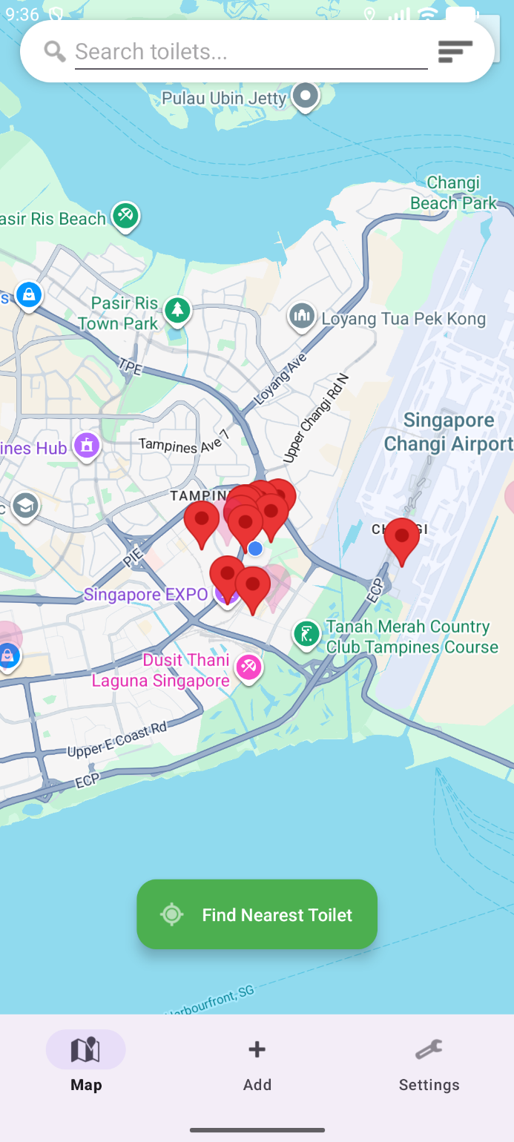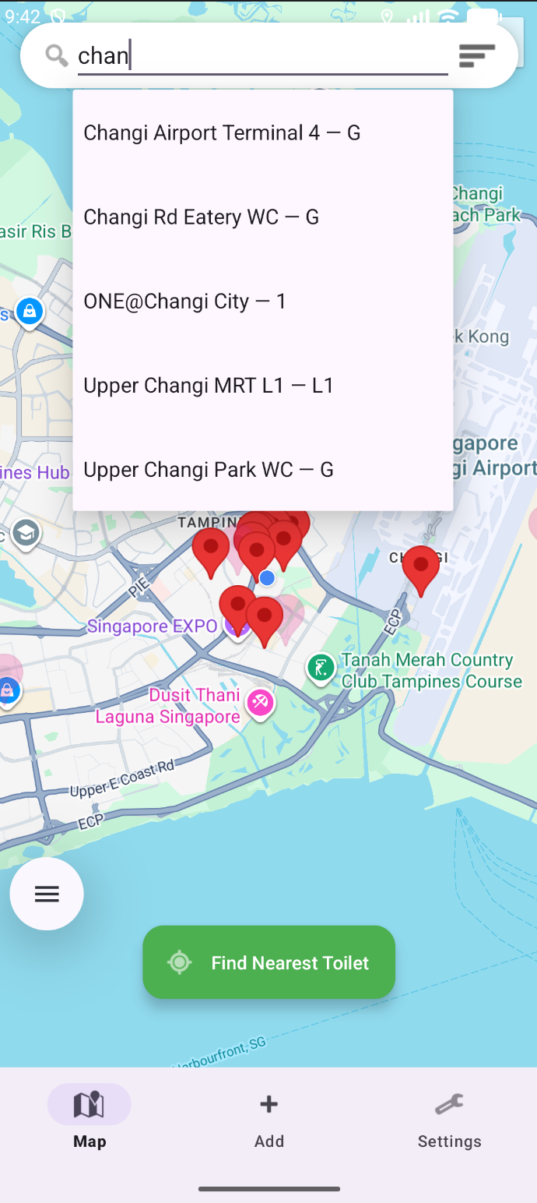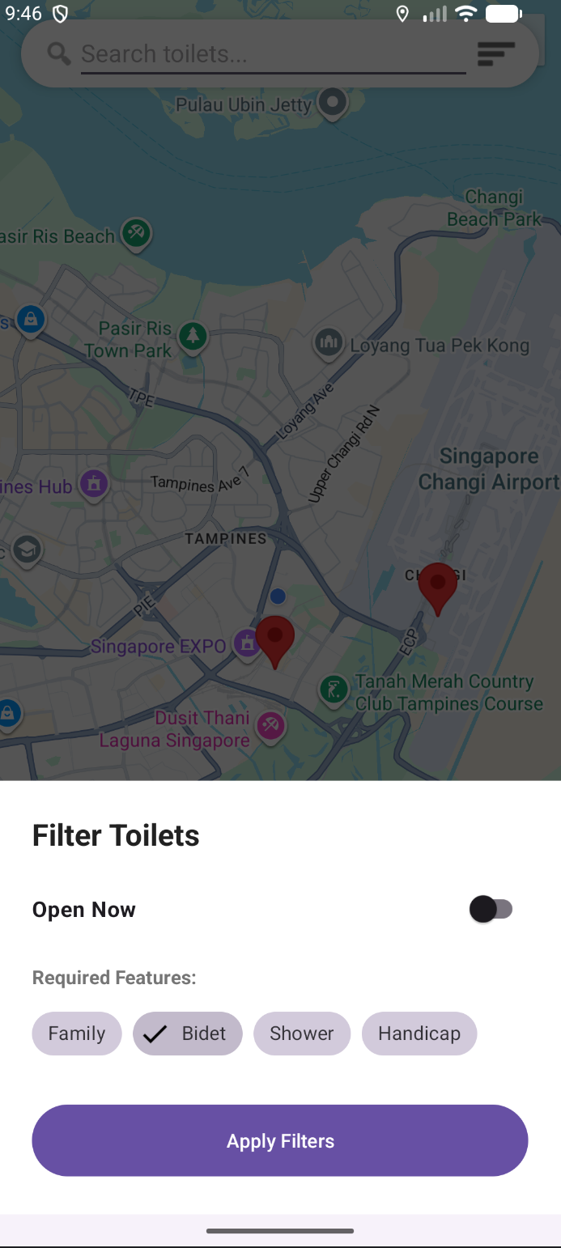
Main Map Page Search Bar Feature Filter Feature

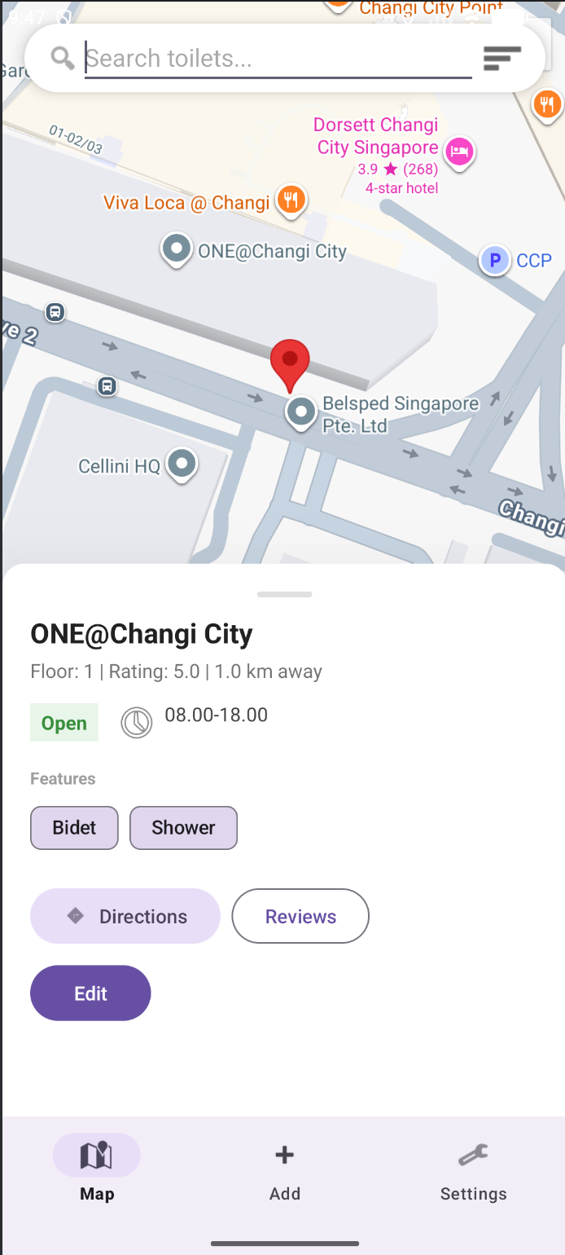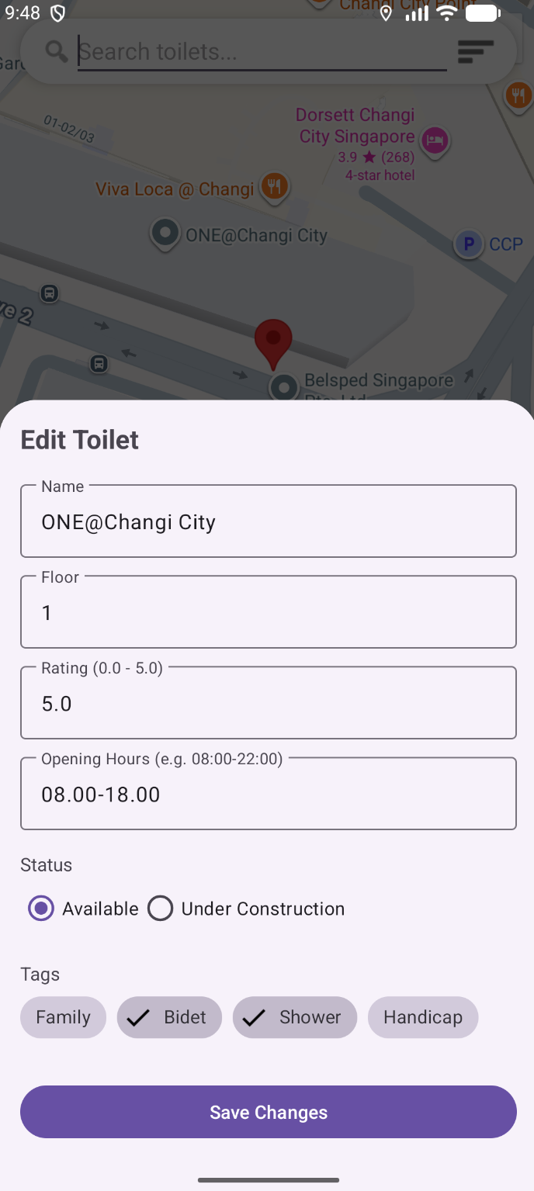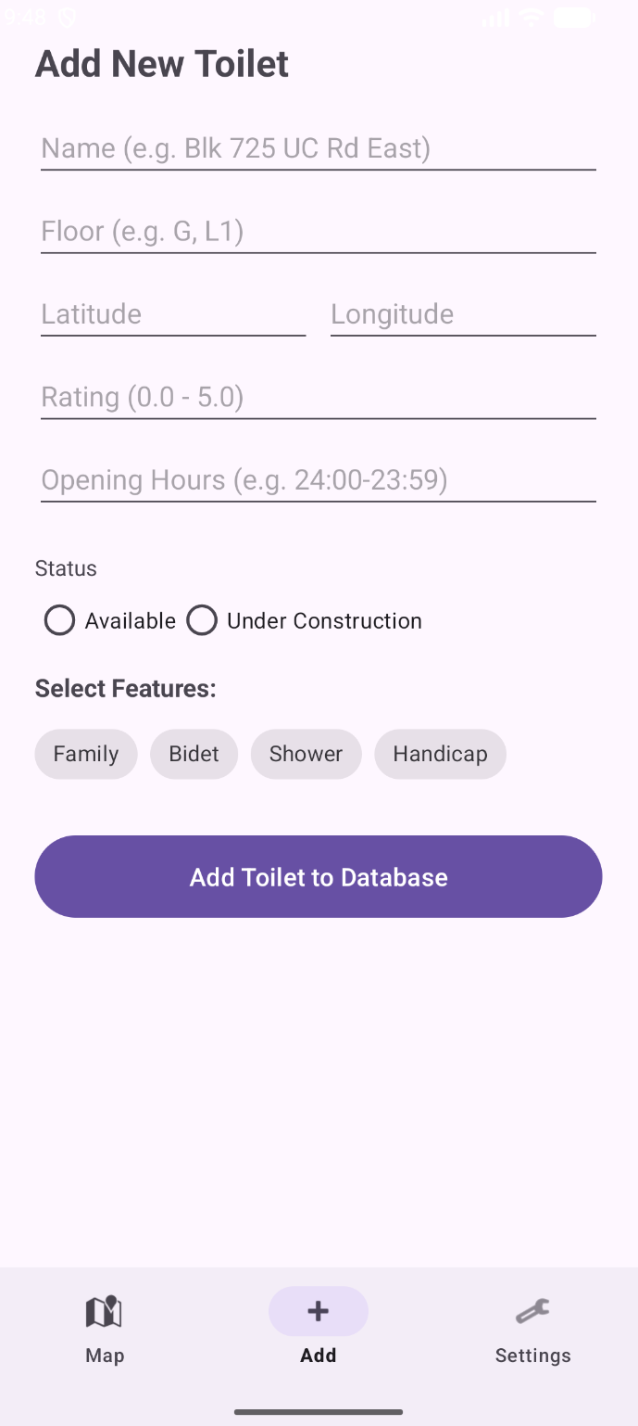
Detail Bottom-sheet Edit Toilets Feature Add Toilets Feature

Hardware
No dedicated hardware components were used. The application runs on standard Android smartphones. Development and testing were conducted on the Android Emulator (Medium Phone, API 36.1) within Android Studio.

System Design and Implementation

System Architecture
KheeHub follows a client-cloud architecture. The Android app (client) communicates with Firebase Firestore (cloud NoSQL database) for all toilet data reads and writes. The Google Maps SDK handles all map rendering, marker management, and navigation handoff. There is no custom backend server; Firebase acts as the backend-as-a-service.
The KheeHub app is structured into the following key classes:
• MainActivity.java — Entry point; handles navigation between fragments
• MapFragment.java — Core fragment; manages the map, marker rendering, filtering, search, nearest-toilet logic, and bottom sheet UI
• ToiletSearchAdapter.java — Custom ArrayAdapter implementing Filterable for autocomplete search
• Toilet.java — Plain Java Object (POJO) modelling the toilet data entity
• ToiletRepository.java — Abstraction layer for Firestore Create, Read, Update, and Delete (CRUD) operations
• AddFragment.java — Form UI for adding new toilets to Firestore

Hardward Used
No physical hardware was used beyond standard Android development devices. Testing was performed exclusively on the Android Emulator bundled with Android Studio.

2D aspect

Data structure

ArrayList / List
Three ArrayList instances are maintained in MapFragment:
- allToilets (List<Toilet>) stores the full set of toilet objects downloaded from Firestore;
- allMarkers (List<Marker>) stores the corresponding Google Maps marker references for each toilet; and
- currentSelectedTags (List<String>) tracks which filter tags the user has currently activated.
ArrayList was chosen because all operations are sequential iteration and the size is dynamic as toilets are added or downloaded from Firestore. The Java standard library ArrayList<> implementation was used directly.

HashMap
A Map<String, Object> (backed by HashMap) is used in the toilet update flow. When a user edits a toilet, the changed fields (name, floor, rating, openingHours, status, tags) are packed into a HashMap and passed as a partial-update payload to Firestore's updateToilet() method. HashMap was chosen because Firestore's update API accepts a map of field-name strings to new values, making the String → Object key-value structure a natural fit. The Java standard library HashMap<> was used.

Algorithm

Linear Search — O(n)
The searchForToilet(String query) method in MapFragment performs a linear scan over allToilets, checking whether each toilet's name or floor field contains the query string (case-insensitive). This populates the autocomplete suggestions list. Time complexity is O(n) where n is the number of toilets. A linear search was chosen because the dataset is small (for current version of the app), making the overhead of building an index (e.g., a Trie) unjustified. The implementation is written from scratch without external libraries.

Nearest Neighbour Search — O(n)
The Find Nearest Toilet feature iterates over all toilet objects in allToilets, computing the geodesic distance from the user's current GPS location to each toilet using Android's Location.distanceBetween() static method (which uses the WGS-84 ellipsoid model). A running minimum tracks the closest candidate. Only toilets that are currently open and match active tag filters are considered. Time complexity is O(n). A spatial index (k-d tree) would reduce this to O(log n) for large datasets, but at the scale of Singapore's public toilets, the linear scan completes near-instantaneously. The Location.distanceBetween() method is from the Android SDK; the nearest-neighbour loop itself was written by the team.

Filter / Predicate Matching — O(n × m)
The applyFilters() method scans allMarkers (O(n)) and for each marker, checks whether its associated Toilet satisfies all m currently selected tag predicates (O(m) inner loop), yielding O(n × m) total. A marker is shown only if matchesTags && matchesOpen. The implementation uses Java's List.contains() for tag checking. Written by the team without external libraries.

Resource Used

Stack Overflow
Debugging — community answers on Android, Firestore, and Google Maps SDK issues

YouTube Tutorials
Exploring Android development patterns and Firebase integration walkthroughs

GeeksForGeeks
Java syntax reference — ArrayList, HashMap, Comparator patterns

Claude Code (Anthropic)
Debugging and code advice at specific points

Google Gemini
Debugging and code advice at specific points

GitHub Copilot
In-editor code suggestions and debugging

Project Management

Name | Primary Responsibility
Thong Zi Qi | Frontend
Tan Yu Min | Backend development
Korakrit Tonpongphan | Google Maps API integration & Firebase setup
Krittawee Chaiprasertsud | Full-stack development + 2D Report
Purinut Larpsiriwatkul | Full-stack development + 2D Report
Lukas Ho | Backend development
Sanjan Krishna | Frontend

Financial Report
The team did not spend any portion of the budget, as all tools and services used — including Firebase Firestore, Google Maps SDK, and Android Studio — were available for free. No hardware or paid subscriptions were required. The full $80.00 remains unspent.

Conclusion and Future Work

Conclusion
KheeHub successfully demonstrates a functional, well-structured Android application that addresses a real and relatable urban problem: finding a clean, open public toilet quickly under urgent conditions. The prototype meets all Must-Have requirements (toilet database, status, tags, one-click nearest-toilet search, user contributions) and has made progress on Should-Have features (navigation). The codebase exhibits sound OOP principles including DRY, Separation of Concerns, Loose Coupling, and clean data modelling, and makes effective use of the Google Maps SDK and Firebase Firestore as the core technical infrastructure.

Future Plan
• Real-time toilet traffic: Integrate anonymised usage reporting so users can see live congestion levels (Low / Medium / High) at each toilet, helping them avoid queues.
• Cleaning schedule display: Surface cleaning schedules stored in Firestore so users can avoid visiting during active cleaning periods.
• Advanced multi-floor navigation: Implement indoor routing for multi-storey buildings, showing users not just which floor the toilet is on but how to get there from their current floor.
• Aesthetic UI redesign: Apply Material Design 3 guidelines, improved colour palettes, smooth animations, and a polished icon set for a production-quality user experience.
• Rating submission UI: Build a star-rating dialog so users can submit ratings directly within the app rather than through the edit screen.
• Water cooler locator: Extend the database to include nearby water coolers, making KheeHub a broader urban utility finder.
• iOS port: Develop a Swift / SwiftUI counterpart to reach iPhone users.

References
[1] Google LLC. Google Maps SDK for Android Documentation. https://developers.google.com/maps/documentation/android-sdk
[2] Google LLC. Firebase Firestore Documentation. https://firebase.google.com/docs/firestore
[3] Android Developers. Location.distanceBetween(). https://developer.android.com/reference/android/location/Location#distanceBetween%28double,%20double,%20double,%20double,%20float)
[4] Android Developers. AutoCompleteTextView. https://developer.android.com/reference/android/widget/AutoCompleteTextView
[5] Android Developers. Filterable Interface. https://developer.android.com/reference/android/widget/Filterable
[6] Stack Overflow. Community answers on Firestore Java deserialization, Android Map SDK, and related topics. https://stackoverflow.com
[7] GeeksForGeeks. Java Collections Framework — ArrayList and HashMap. https://www.geeksforgeeks.org/java-util-arraylist
[8] Anthropic. Claude Code. https://claude.ai/code
[9] Google DeepMind. Google Gemini. https://gemini.google.com
[10] GitHub. GitHub Copilot. https://github.com/features/copilot

- Background
- describe your problem and your proposed solution
- How your solution addresses sustainability goals, diversity and inclusion (one short paragraph will do)
- Summary of your prototype
- Brief description of the features, screenshots of key UI components
- Pictures of hardware or other items used, if any
- System Design and Implementation: includes but not limited to
- system architecture
- detailed description of hardware used, if any
- OOP principles used, if any
- design patterns used, if any
- Highlight the parts of your project that did not use Java and explain why
- any other key technical features to highlight (e.g. external APIs used, frameworks used etc)
- 2D aspect
- What data structure(s) or algorithm(s) did you choose and reason for your choice
- Describe how did you implement it in the code. Did you use code from the Java library? Used some else’s implementation? Did you write it yourself?
- Resources Used
- Description of resources used in your project e.g. documentation, external tools, LLMs etc
- Explain in detail how one resource was helpful for your project, and to what extent
- Project Management – A summary showing who was responsible for what, and how your team used to manage the tasks in this project
- Financial Report – How did you spend the $80 project budget?
- Conclusion and Future work
- References

